**Stock Market and Scam**

**Students Name :** Smit Kalpesh Vasani

**Matriculation :** 92120071

**Professor’s Name :** Giefer Lino Antoni

**Course :** Programming with Python

**Abstract**

Scandals are often the “tip of the iceberg”. They represent the "visible‟ catastrophic failures. An attempt is made in this paper to examine in-depth and analyze India‘s Enron, Satyam Computer‘s “creative-accounting” scandal. Their scandal/fraud has put a big question mark on the entire corporate governance system in India. In public companies, this type of 'creative‘ accounting leading to fraud and investigations are, therefore, launched by the various governmental oversight agencies. The accounting fraud committed by the founders of Satyam in 2009 is a testament to the fact that ―the science of conduct is swayed in large by human greed, ambition, and hunger for power, money, fame and glory. Scandals have proved that ―there is an urgent need for good conduct based on strong corporate governance, ethics and accounting & auditing standards. Unlike Enron, which sank due to 'agency‘ problem, Satyam was brought to its knee due to 'tunneling‘ effect. The Satyam scandal highlights the importance of securities laws and CG in emerging markets. Indeed, Satyam fraud ―spurred the government of India to tighten the CG norms to prevent recurrence of similar frauds in future. Thus, major financial reporting frauds need to be studied for 'lessons-learned‘ and 'strategies-to-follow‘ to reduce the incidents of such frauds in the future. The increasing rate of white-collar crimes ―demands stiff penalties, exemplary punishments, and effective enforcement of law with the right spirit.

**Contents**

1. **Introduction**
2. **Literature Review**
3. **Methodology**
4. **Data Analysis**
5. **Bibliography**
6. **Conclusion**
7. **Appendix**

**Table of Figures**

Table 1: Linear regression results 15

Figure 1: Salary vs Years of Experience 11

Figure 2: Linear Regression Results 12

Figure 3: Polynomial Regression Results 13

Figure 4: Difference Between Polynomial and Linear Model Predictions 14

Figure 5: Relationship between years of experience and salary. 16

**Introduction**

Satyam Computer Services Ltd was founded in 1987 by B. Ramalinga Raju. The company offers information technology (IT) services spanning various sectors, and is listed on the New York Stock Exchange and Euro next. Satyam's network covers 67 countries across six continents. The company employs 40,000 IT professionals across development centers in India, the United States, the United Kingdom, the United Arab Emirates, Canada, Hungary, Singapore, Malaysia, China, Japan, Egypt and Australia. It serves over 654 global companies, 185 of which are Fortune 500 corporations. Satyam has strategic technology and marketing alliances with over 50 companies. Apart from Hyderabad, it has development centers in India at Bangalore, Chennai, Pune, Mumbai, Nagpur, Delhi, Kolkata, Bhubaneswar, and Visakhapatnam. "The truth is as old as the hills" opined Mahatma Gandhi, christened the Father of the Nation by Indians. So a company named "Satyam" (Truth, in Sanskrit) inspired trust. The IT boom in India, was fuelled by young, middle-class, and educated, budding Indian entrepreneurs and Western firms anxious to outsource to take advantage of high-skill, lowwage worker. This trend created a new breed of businessmen for the 21st century and generated many fortunes literally overnight. The global corporate community was flabbergasted and scandalized when the Chairman of Satyam, Mr. Ramalinga Raju resigned on 7th January, 2009 and confessed that he had manipulated the accounts by $1.47-billion.

**Literature Review**

The fraud was detected by investment bank DSP Merrill Lynch when its auditors found numerous irregularities in Satyam’s financial statements (Caliyurt & Idowu, 2012). The bank had been hired by the company to find either a partner or a buyer. After discovering financial irregularities, the bank terminated its working relationship with Satyam (Brooks & Dunn, 2014). Raju’s resignation was initiated by the bank’s decision to reveal its unethical accounting practices to the public (Brooks & Dunn, 2014). Prior to the fraud detection, the chairman encouraged unethical accounting practices because he thought that his decisions would have long-term financial benefits to the company. He stated that his actions were aimed at helping investors grow their investments (Caliyurt & Idowu, 2012). However, the effects of his decisions were so severe that it became difficult to hide the company’s poor financial situation.

The company’s investors became suspicious when the chairman presented a proposal to buy two companies affiliated with his family for $1.6 billion (Brooks & Dunn, 2014). After rejecting the proposal, the chairman had no other strategy to conceal the marginal gap that had been created by many years of unethical accounting practices. The rejection of the proposal by institutional investors was a big blow to Raju and his team because they had exhausted their options (Nag, 2013). The fraud was finally exposed after Raju wrote to employees admitting to engagement in unethical accounting practices in order to misrepresent the company’s financial situation (Caliyurt & Idowu, 2012). The company had reached a dead point because the marginal gap between the real financial figures and the virtual ones became so big that Raju could not hide it anymore. Had he not disclosed his illegal dealings to employees, the company would have collapsed because of insufficient cash flow to run its operations. On January 9, 2009, Raju resigned as Satyam’s chairman after confessing that the company had been engaging in illegal accounting practices for many years (Brooks & Dunn, 2014).

After the fraud was exposed, Merrill Lynch terminated its working relationship with Saytam, PriceWaterhouseCoopers was investigated and suspended from operating, Credit Suisse dropped Satyam as a client, and the awards given to the company as well as its executives were taken back (Caliyurt & Idowu, 2012). The share price fell drastically and investors lost about $2.28 billion (Brooks & Dunn, 2014). Participants were arrested and investigated for participating in the fraud. The Ensex index declined by more than 5% and the company’s share price fell by more than 70%. The government appointed new board members to find a solution that would mitigate the problem and prevent the company’s collapse (Caliyurt & Idowu, 2012). The board was responsible for finding a buyer for the company within 100 days. Finally, the company was sold to Tech Mahindra. After the buyout of the company, the stock prices again started to rise exponentially as whole management behind the company was reformed and a trustable brand of Mahindra was backing the company.

**Methodology**

The analysis is based on the data being provided. The sample included here was quite random and the demographics could not be fully established. Therefore, it is expected that most of the biases or corrections linked to a given demographics were not included in the study. However, it is still worth noting that we are not fully certain of how the websites and the platforms collected their data, leading to some uncertainty in the reliability of the data as an authentic source of information on the salaries of various employees. The data comprised 401 data points representing various levels of years and stock prices(not value accurate but in multiplications). The mean of years before and after scam is 3.0323846452817502 and the mean stock price is 50.011408004100005(x10Rs).

**Data Analysis**

From figure 1, we can observe that the relationship is not perfectly linear, indicating that the data can not only be modeled using a linear regression model but also polynomial regression. However, Pattison and Cragie (2022), indicate that polynomial regression models are more suitable for explaining complex relationships such as those of Stock Price and Events in Years that depend on several factors. The application of polynomial regression is applicable in this case since it covers a wide range of data changes that cannot be covered by a linear model. However, in some cases, the addition of a polynomial factor to the model does not have a significant impact on the model since the number of polynomial elements does not improve the overall model. Therefore, both linear and polynomial models will be considered as a possible solutions to the problem. The difference between the models will be evaluated to understand their impact on the overall model

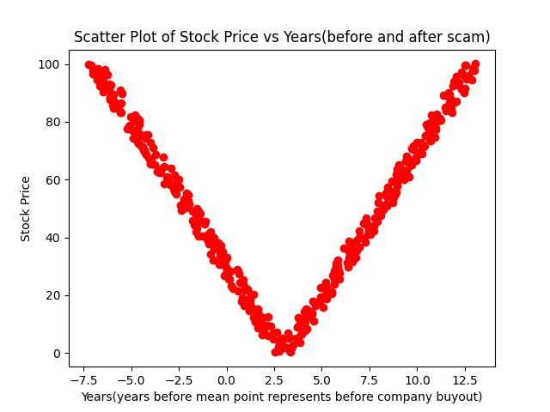

Figure 1: Stock Price vs Years(befroe and after scam

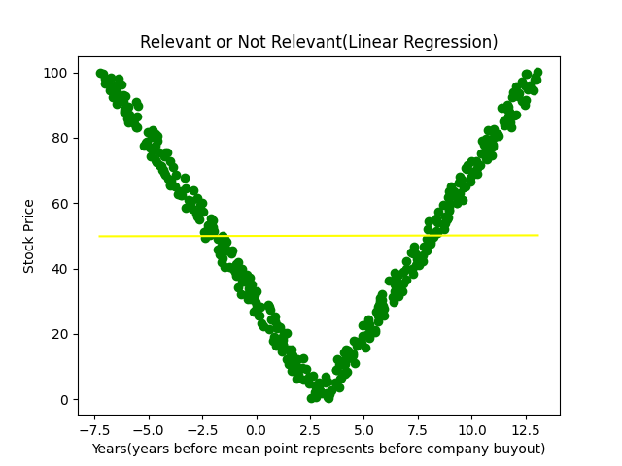

Figure 2: Linear Regression Results

Figures 2 and 3 indicate the difference between the results generated from the two models. It is clear that the two models had distinct results when evaluated against the test dataset. Therefore, both models seem to have a differenct prediction capability for the provided dataset. From figure 4 below, it is clear that the difference between the models is significantly large and varies randomly.

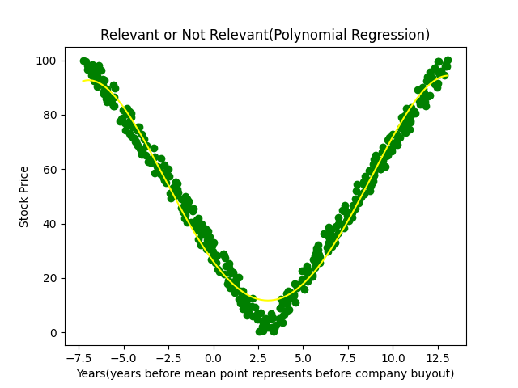

Figure 3: Polynomial Regression Results

Further comparison of the models can be done by predicting data out of the dataset such as 6 years after buyout. The prediction for the polynomial model was 25.413197413759328(x10Rs) while the prediction for the linear model was 50.05444777536012(x10Rs). Therefore, the models do have a significant differencr indicating they do have a vast difference.

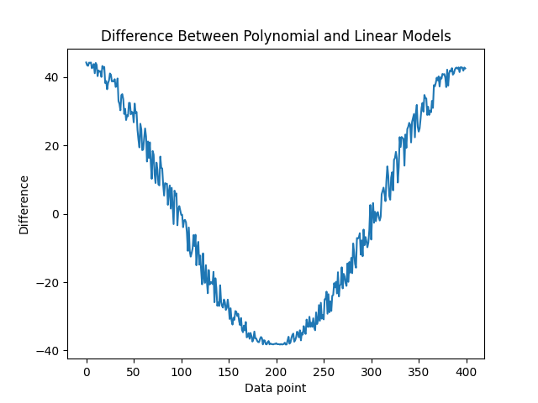

Figure 4: Difference Between Polynomial and Linear Model Predictions

Table 1 below presents the summary statistics of the linear model generated from the data. Evaluating the R-square and the adjusted R-square, we can see that that model does not describes the data since the R-square is 0.044. Furthermore, the F statistic was 2.997 which is significantly low. Therefore, the model can not confidently explain the changes in the data presented. Therefore, we can assume that the model alone can not be used to interpret stock price of company after the buyout.

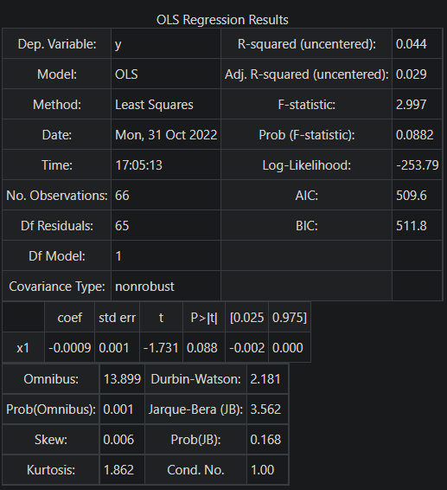

Table 1: Linear regression results

Table 2 below presents the summary statistics of the linear model generated from the data. Evaluating the R-square and the adjusted R-square, we can see that that model almost perfectly describes the data since the R-square is 0.126. Furthermore, the F statistic is 46 which is significantly high. Therefore, the model can confidently explain the changes in the data presented. The p-value was also significantly low, further supporting the R-square values and F statistic values evaluated before. Evaluating the model significance at a 5% level of significance, it is clear that the model is significant since the p-value was 0.00 which is less than 0.05. Therefore, we can assume that the model can be used to interpret stock price of company after the buyout.

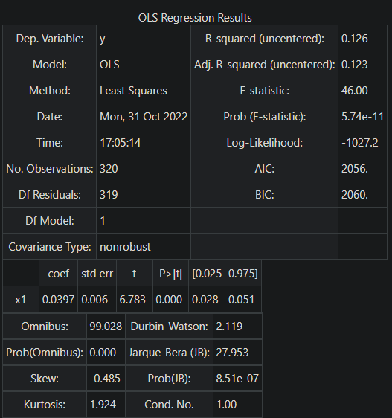

Table 2: Polynomial regression results

**Conclusion**

The Satyam accounting fraud is the largest fraud scandal to happen in the history of India. It was conducted over a period of about 10 years by the company’s chairman and other top executives. It is evident from the foregoing discussion that Satyam’s management did not honor the code of ethics and standards that govern the accounting profession. They inflated their financial accounts in order to present a false image of their company’s financial performance. The scandal was exposed by Merrill Lynch after discovering financial inconsistencies in the financial statements of Satyam. The chairman and other top executives resigned, the company’s share price fell drastically, investors lost $2.2 billion, and the government appointed a board to handle the situation. The company was sold to Tech Mahindra, and the two entities merged to form Mahindra Satyam. The Satyam accounting fraud occurred due to many years of financial manipulation of accounts that was intended to fool investors and the public into believing that Satyam was performing well financially. Such occurrences can be avoided by adhering to accounting ethics, honoring business ethics, and by promoting transparency and accountability within organizations.

**Bibliography**

* IvyPanda. (2020, August 13). Satyam Scandal, Its Detection and Aftermath. https://ivypanda.com/essays/satyam-scandal-its-detection-and-aftermath/
* Banerjee, R. (2015). Who cheats now: Scams, frauds and the dark side of the corporate world. New York, NY: SAGE Publications.
* Basilico, E., Grove, H., & Patelli, L. (2012). Asia’s Enron: Satyam. Journal of Forensic & Investigative Accounting, 4(2), 142-160.
* Bhandari, B. (2009). The Satyam saga. New York, NY: Business Standard Books.
* Bhasin, M. (2016). Creative accounting practices at Satyam computers limited: A case study of India’s Enron. International Journal of Business and Social Research 6(6), 24-48.
* Bhasin, M. L. (2013). Corporate accounting fraud: A case study of Satyam computers limited. Open Journal of Accounting, 2, 26-38.
* Brooks, L. J., & Dunn, P. (2014). Business & professional ethics. New York, NY: Cengage Learning.

**Appendix**

Github Link :

Main Code :

import pandas as pan  
import numpy as num  
import matplotlib.pyplot as plot  
from sklearn.linear_model import LinearRegression  
from sklearn.model_selection import train_test_split  
from sklearn.preprocessing import PolynomialFeatures  
  
# Importing the dataset train.csv  
dataset = pan.read_csv('train.csv')  
x = dataset.iloc[:, 1:2].values  
y = dataset.iloc[:, 4].values  
year = dataset["y1"]  
print("The mean of Years(before and after scam)", num.mean(x))  
print("The mean of Stock Price of Company", num.mean(y))  
  
# Dataset being split into training set and test set  
x_train, x_test, y_train, y_test = train_test_split(x, y, test_size=0.2, random_state=0)  
plot.scatter(x,y, color="red")  
plot.title('Scatter Plot of Stock Price vs Years(before and after scam)')  
plot.xlabel('Years(years before mean point represents before company buyout)')  
plot.ylabel('Stock Price')  
plot.show()  
  
# Representation of Liner Regression  
lin_reg = LinearRegression()  
lin_reg.fit(x, y)  
  
# Linear Regression Results   
def linear_reg():  
 plot.scatter(x, y, color='green')  
 plot.plot(x, lin_reg.predict(x), color='yellow')  
 plot.title('Relevant or Not Relevant(Linear Regression)')  
 plot.xlabel('Years(years before mean point represents before company buyout)')  
 plot.ylabel('Stock Price')  
 plot.show()  
 return  
linear_reg()  
  
# Representation of Polynomial Regression  
polynom_reg = PolynomialFeatures(degree=4)  
X_poly = polynom_reg.fit_transform(x)  
pol_reg = LinearRegression()  
pol_reg.fit(X_poly, y)  
  
# Polynomial Regression Results  
def polynomial_reg():  
 plot.scatter(x, y, color='green')  
 plot.plot(x, pol_reg.predict(polynom_reg.fit_transform(x)), color='yellow')  
 plot.title('Relevant or Not Relevant(Polynomial Regression)')  
 plot.xlabel('Years(years before mean point represents before company buyout)')  
 plot.ylabel('Stock Price')  
 plot.show()  
 return  
polynomial_reg()  
  
# Smoothening the plot line  
def polymonial_smooth():  
 x_grid = num.arange(min(x), max(x), 0.1)  
 x_grid = x_grid.reshape(len(x_grid), 1)  
 # Visualizing the Polynomial Regression results  
 plot.scatter(x, y, color='green')  
 plot.plot(x_grid, pol_reg.predict(polynom_reg.fit_transform(x_grid)), color='yellow')  
 plot.title('Relevant or Not Relevant(Polynomial Regression)')  
 plot.xlabel('Years(years before mean point represents before company buyout)')  
 plot.ylabel('Stock Price')  
 plot.show()  
 return  
  
def visualize_difference():  
 polynomial_results = pol_reg.predict(polynom_reg.fit_transform(x))  
 linear_results = lin_reg.predict(x)  
 difference = polynomial_results-linear_results  
 plot.plot(difference)  
 plot.title('Difference Between Polynomial and Linear Models')  
 plot.xlabel('Data point')  
 plot.ylabel('Difference')  
 plot.show()  
  
polymonial_smooth()  
visualize_difference()  
print("Predicted Stock Price after 6 Years")  
# New Result Prediction after 6 years with Linear Regression  
linear_results=lin_reg.predict([[6]])  
print("Linear Results",linear_results[0])  
  
# New Result Prediction after 6 years with Polynomial Regression  
  
polynomial_results=pol_reg.predict(polynom_reg.fit_transform([[6]]))  
print("Polynomial Results",polynomial_results[0])